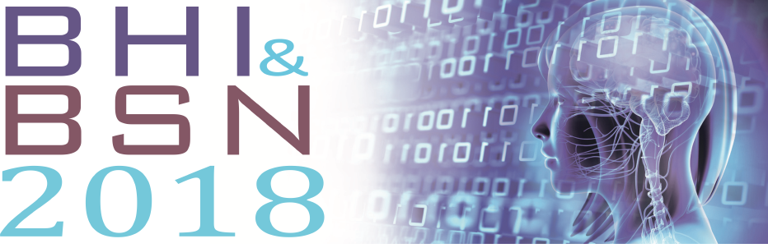
You are cordially invited to join us at the International Conference on Biomedical and Health Informatics, BHI'18. This prestigious event will be held 4-7 March 2018 at the Treasure Island Hotel, Las Vegas, Nevada, USA.
The IEEE International Conference on Biomedical and Health Informatics (BHI) is the flagship conference of IEEE Engineering in Medicine and Biology Society (IEEE-EMBS) on the specific topic of informatics and computing in healthcare and life sciences. BHI’18 is being co-located with the annual IEEE BSN’18 Conference and HIMSS Conference & Exhibition in Las Vegas.
The main theme of the BHI-2018 is the “Informatics for Smart, Precision and Preventive Medicine.” Advancing health informatics has been identified as a grand challenge for engineering in the 21st century by the National Academy of Engineering. Managing and improving human health and curing complex diseases will require novel and creative informatics methods and solutions to accelerate scientific discovery, translate discoveries into successful treatments, re-engineer care practices and infrastructure for precision and preventive medicine, and harvest big data to improve care, save lives and lower costs.
Please note that this invitation for participation does not, in any way, financially oblige either BHI’18 or the IEEE Engineering in Medicine and Biology Society (EMBS) for the expenses you incur for travel and conference attendance, and all conference participants are expected to pay the registration fees according to conference policy. You will have access to a more customized Invitation letter (to include your name and paper information) once your paper has been accepted.
Please visit http://bhi-ban.embs.org/2018/ to learn more. We look forward to your participation in BHI’18!
Sincerely,
Dimitrios I Fotiadis, JBHI EiC, Univ of Ioannina, Greece
Julien Penders, Bloomfield, USA
May D. Wang, Georgia Tech and Emory University, USA
BHI’18 Conference Chairs

